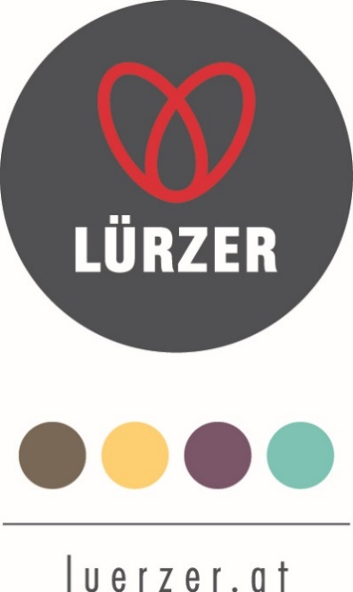

SEMINARS & CONGRESSES

at the Sporthotel Edelweiss

on 1750 m

Congress room bookable for at least 20 People

Conference Technology at the „Bergblick“

Flipcharts with paper
Seminar pads and pens
Pin board
DVD player
CD player
Sound-System
Beamer
Canvas
W-Lan
Interfaces for Notebooks

You can order special conference technology for your wishes for cost price.

Seminar room price included the conference technology € 200, - per day.
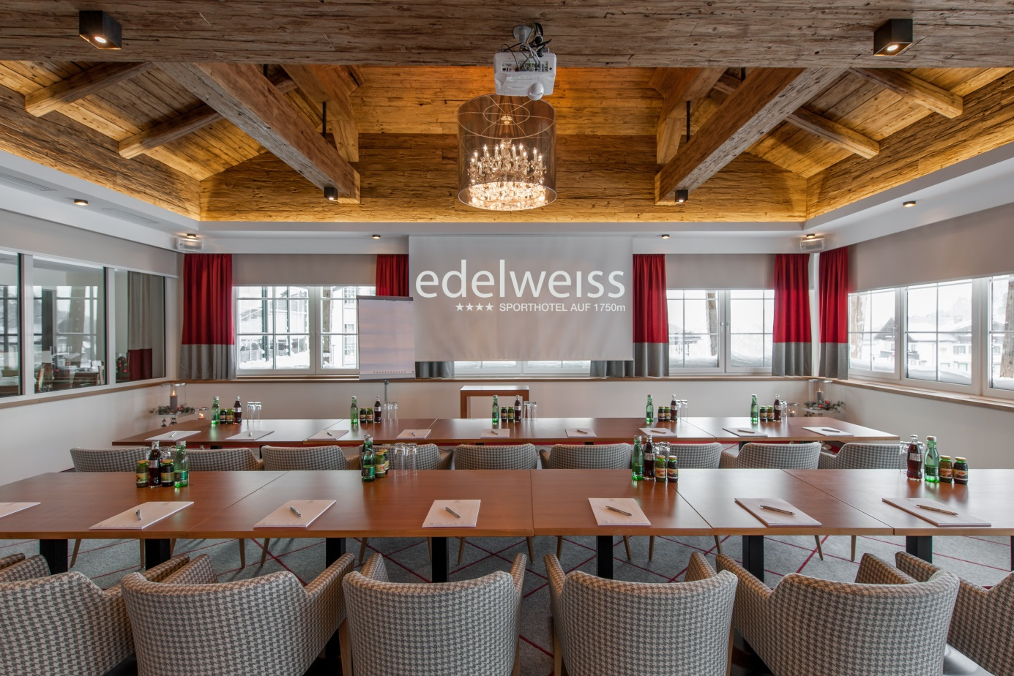

4****s Comfort at the Sporthotel

What you expect at the “Sporthotel Edelweiss” in Obertauern
The „ Sporthotel Edelweiss“offers you an outstanding service, the best equipment and the best benefits.

One sight:
- 4 stars superior comfort ,wellness- and seminar hotel
- central location, near the shops and the bars in Obertauern
- direct access to the slopes and the ski lifts next to the hotel
- welcome present and a mineral water in the sports and modern fitted rooms and apartments
- free bath robe service and slippers
- big breakfast buffet with regional products from 07:30 am to 10:30 am, „Late sleepers breakfast“ from 10.30 am – 11.30 am at the restaurant “Steinbock”
- À la carte restaurant "Steinbock" – we serve traditional, Austrian and modern food from 11:00 am – 09:30 pm. Table reservations recommended: steinbock@luerzer.at or 0043 6456 7245 603
- Cocktail bar with fireplace
- ski rental „Freudenhaus“ directly at the hotel
- 850m² wellness area with an indoor pool, whirlpool, finish sauna, steam- and brine grotto, old wooden-bio sauna, infrared-sauna with Flat-TV
- vital bar at the wellness area with fresh juices, mountain spring water and healthy snacks
- massage area with an great after-feeling
- High modern fitness area with an panoramic view on the mountains of Obertauern
- locker room – for placing luggage, to have a shower or to change clothes
- free WLAN at the hotel
- home owned ski school in Obertauern „Frau Holle“ (groups and individual lessons), special kids-ski courses with an final race, exercise slope with an lift for kids and beginners next to the hotel
- ski in- ski out with the contactless ski- keycard – ski pass for 1-8 days, you ski pass is the room key also
- Après-ski at its finest: the famous „Lürzer Alm“ is 50m from the Hotel
- sports- and fashion shop „FREUDENHAUS“, with an coffee and trendy bar-lounge, 50m from the hotel
- Care parking spaces in front of the hotel for free

Extra Charge:
- massages, solarium
- newspaper service
- garage parking space (at the „FREUDENHAUS“ 50 m from the hotel)
- Home owned ski school in Obertauern „Frau Holle“(groups and individual lesions),
special kids-ski courses with a final race.
- Ski rent and ski service (at the home own ski rent „FREUDENHAUS“)
- Ski pass (1 to 8 days) directly at the reception – the ski pass is also your room key
- airport-transfer to Salzburg – on demand

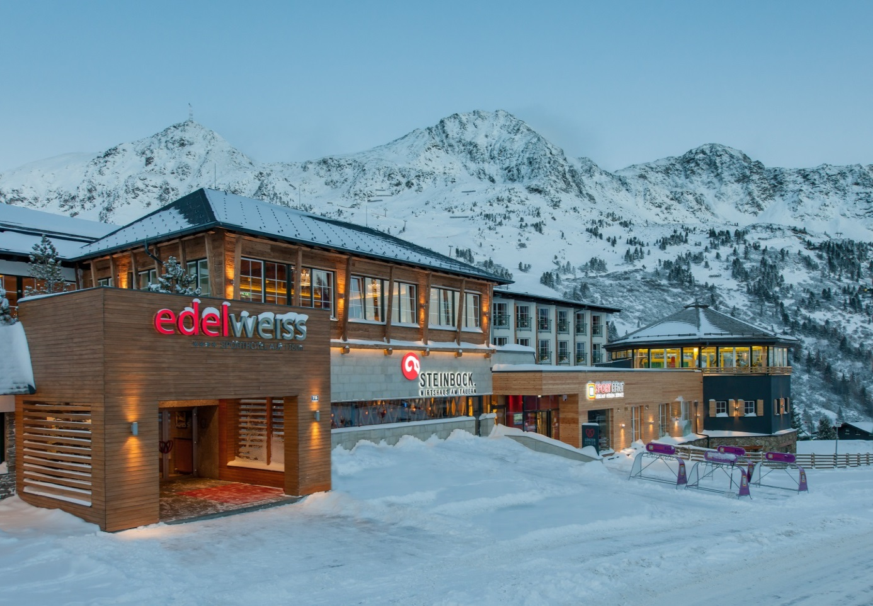

SMALL SNACKS & BUFFET SUGGESTIONS

Coffee break 1

Coffee, tea section
Orange-, apple- and multi vitamin juice
Fresh fruit
Euro 8,20

Coffee break 2

Coffee, tea section
Orange-, apple- and multi vitamin juice
Oven- fresh Danish pastries
Euro 10,50

Coffee break 3

Coffee, tea section
Orange-, apple- and multi vitamin juice
Sandwiches
Euro 11,50

Snacks for your coffee break

Brioche croissant Euro 2,50
Croissant Euro 2,50
Apple- or curd strudel Euro 3,80

Exquisite fruit platter Euro 7,50

Vegetables-sticks with herb dip Euro 3,50
Grissini with raw ham Euro 4,50
Whole- grand bread rolls with gervais und liptauer Euro 3,50

The price is per person or per portion.

Canapés and sandwiches

Minced meat on pumpkin bread
Prosciutto on baguette with melon
Tomato mozzarella with pesto

Cap of rump Carpaccio with horseradish sauce and pumpkin seed oil
Tuna salad on toast with olives
Bacon with cucumber and egg

à Euro 3,80

Beef Tartar on toast
Marinated tuna on sprouts with toast
Smoked salmon with capers and horseradish
Roastbeef rolls with asparagus on whole grain

à Euro 4,50

Warm Cocktail alternatives

Small escalope on a potato and cucumber salad
Mini porcini ravioli with rosemary butter
Shrimp skewers in glass noodles salad
Fried chicken pieces in crispy breading

à Euro 5,50

BUFFETSUGGETIONS for 20 people:

Italian Buffet

Salads and antipasti with dressing of your choice from the buffet

Minestrone with pasta

Ligurian bread salad with bresaola and parmesan shavings
Piccata Milanese from turkey with pesto spaghetti and tomato sauce
Mediterranean roast beef with capers and olives with rosemary gnocchi
Grilled sea bass on mediterranean vegetables

Panna cotta with orange fillets
Tiramisu with berry ragout,
Coffee ice cream with amarena cherries

Euro 38, - per person

Austrian Buffet

Bacon from Salzburg with pickled onions
Smoked trout mousse as well as smoked fillets and dill mustard sauce
Roast beef rolls with tartare sauce
Sheep cheese terrine with tomato ragout

Local salads from the buffet

Clear ox - bouillon with fries or pumpkin cream soup with oil and seeds

Small escalope with parsley potatoes and lingonberries
Roasted char on leaf spinach and white wine sauce
Styrian root meat with fresh horseradish and boiled potatoes

Apple strudel, curd strudel with vanilla sauce or
Baked apple slices with cranberry ice cream

Euro 36, - per person

Other variants on request.

KULINARIK-NIGHTLIFE-ÀPRES-SKI:

Restaurant „Steinbock“: directly at the “Sporthotel Edelweiss”. Cozy, rustically designed restaurant with tasty and traditional dishes

Lürzer Alm: just a few minutes’ walk from the hotel.
The parties are legendary. The hospitality is huge.
The style-unique. Après ski on a grand scale

MUNDWERK: Gastronomy concept "Fresh Food Fast" at the “FREUDENHAUS” with a stylish restaurant ambience, cozy atmosphere and exuberant nightlife.

Edelweissalm: 1,850 m above everyday’s life. Huge sun terrace for unforgettable après ski parties in the middle of the slopes
Exclusive hut celebration in the evening on request.

Peakini Klubhaus: Restaurant and bar in the middle of the pulsating life of Obertauern

SPORTS-FASHION-LEISURE:

FREUDENHAUS
Our sports and fashion shop offers you the world of fashion and its trends, high-quality winter sports clothing and trendy outfits, when you are away from the slopes, as well as our large RENTAL area with ski and snowboard rental and ski service.
Open daily from 9 am, including Sundays and public holidays.

FREUDENHAUS Rental Filial
“FREUDENHAUS” branch at the “Schaidberg” right next to the “Schaidbergbahn”
“FREUDENHAUS” branch at the “Sporthotel Edelweiss”

FREUDENHAUS Outlet
Trend brands from sports and fashion at top prices.

Taxi FREUDENHAUS
Your personal taxi in Obertauern and to the airport or train station.

Sports center Obertauern
Fitness, games & fun on the top - a meeting point for young and old.

Ski school Obertauern Frau Holle
Ski and snowboard courses, private lessons, children's ski courses, new School & freeride in the “FREUDENHAUS-RENTAL” area.

Framework programs for your event

Tauern circuit with ski instructors
Visit of the Obertauern skiing area with a ski instructor from our in-house ski school "Frau Holle". The conclusion is a stop at the “Lürzer Alm” with a snack.

To cross- county ski in Obertauern
16 km of cross-country ski trails and winter hiking trails in Obertauern.
We would be happy to organize a cross-country skiing instructor for you.

Rental Skis
You can rent skis directly from us at our “Freudenhaus” rental. As a set (skis, sticks and boots) group prices are on request

Snowboots hike
Feeling nature as the most inspiring source of strength can’t hardly be more impressive than on a snow boots hike. Invite your customers and employees to take a deep breath away from the office vibe and exchange fresh thoughts. The glittering snowfields and the glorious sunshine with a stop at the “Edelweissalm” a firework for your eyes. When you arrive at the private hut, a hearty skiers snack and hot drinks await you.

Hut celebration on our „Edelweissalm“
After the ascent with snow boots or with the help of a shuttle (slope machine), we will serve you a delicious dinner in our rustic hut. Fun is definitely guaranteed! Of course, the shuttle will pick you up again after the party.

Bowling at the sports center
The diverse offer also includes a multi-purpose hall for tennis, football and basketball.

Night- tobogganing fun on the „Gnadenalm“
Night tobogganing is a sociable and romantic experience. Under the starry sky, you can go down into the valley as a couple or alone on a sledge. The highlight of the evening is the fun get-together with mulled wine, tea and hearty delicacies in the “Gnadenalm - Stub'n”. Here we talk about similarities, experiences and goals.
Homepage: www.gnadenalm.at, Tel: 06456/7351

Horse Sleigh ride
Romantic drive through the enchanting winter landscape of Obertauern. The taxis will take you to the Gnadenalm; Sleigh ride. Duration approx. 1 hour. Homepage: www.gnadenalm.at, Tel: 06456/7351

Wine or schnapps tasting:
Moderated wine or schnapps tasting with our sommelier. (Price according to agreement).
TRADE TERMS:

Menu cards
We provide menu cards free of charge when using our catering service.

Floral decoration
We are happy to provide any desired floral decorations at cost. Of course, we accept any flower arrangement you provide.

Table setting
Our tables for events are covered with cloth napkins. All menu and buffet prices include table setting per person.

Guarantee number of peoples
In case of firmly reserved events, the number of people specified in the confirmation is deemed to have been agreed. The exact number of people should be confirmed again no later than 5 working days before the start of the event, as this guaranteed number of people will be billed as the minimum number.
If there are more people than guaranteed, we will charge the actual number of people.

Food selection
The exact selection of dishes should be announced up to 7 working days before the start of the event.

Rental costs of the event rooms
Agreed room rents apply exclusively to the provision of the premises.

Billing
Outgoing invoices have to be paid within 7 days without any deductions, otherwise dunning fees and interest will be incurred.

Cancellation conditions
That no cancellation fees are incurred, the written cancellation declaration have to reach us at least 3 months before the agreed arrival date. If you cancel later than 4 weeks before your arrival, we will charge you for the total price of the booked period.

If the reservation gets cancelled, the deposit will be refunded.
This is why we would recommend that you book a travel cancellation insurance.

